

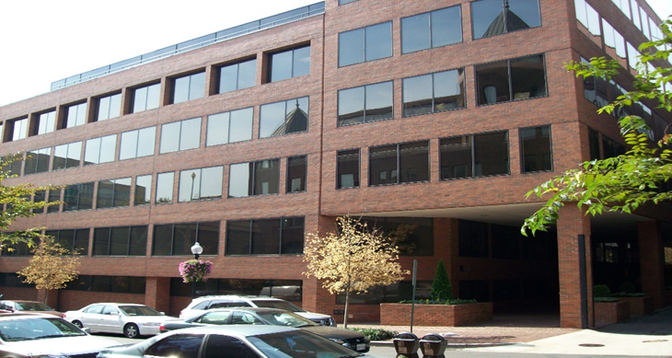

**1000 Thomas Jefferson St NW**

**2020 Floor Warden**

**Training Guide**

**Introduction**

1000 Thomas Jefferson St NW has been designed and constructed to meet or exceed applicable building code requirements for the safety of tenants and visitors. Nevertheless, certain situations may occur that require a prompt response from building staff and tenants prior to the arrival of first responders for their personal security, welfare, and protection of their premises.

It is important to note that the life safety and property protection systems in place at 1000 Thomas Jefferson St NW will only provide the designed security benefit if people respond accordingly.

***Floor wardens are the first lines of defense in an emergency. A comprehensive all-hazards plan, training, and effective communications are keys to an effective emergency response.***

This guide will provide a summary of the life safety systems in the building followed by actions steps based on best practices to be taken in the event of the following emergencies:

* General Evacuation
  + Fire and Non-Fire
* Shelter-in-Place
* Medical Emergency
* Power Failure
* Bomb Threat
* Hazardous Materials Spill
* Tornadoes
* Earthquake
* Elevator Malfunction or Entrapment
* Active Shooter
* Workplace Violence

This guide should be:

* Read
* Understood
* Reviewed periodically and updated as necessary
* Adhered to by all within the tenant’s organization

The property management staff is always available to answer any questions regarding its content or any other life safety issues.

Each tenant is required to appoint at least two individuals within their organization to serve as Floor Warden and Deputy Warden. Each should receive a copy of the Floor Warden Training Guide and ensure the following:

1. All employees understand the procedures, and that the designated floor warden team members read the guide in its’ entirety. In addition, the floor warden team may find it helpful to review any other emergency preparedness information provided by property management, and to attend any emergency preparedness training and seminars provided by JBG SMITH.
2. Personally execute certain procedures and direct the actions of the tenant’s employees during an emergency.
3. Act as the communications contact between the tenant’s employees and property management, and/or the Police and Fire Departments in the event of an emergency.

**Table of Contents**

**Topic Page**

Introduction 1

Table of Contents 3

Emergency Contact List 4

General Preparedness 5

Emergency Communications 5

Fire/Life Safety Systems 6

Building Emergency Response Team 8

Floor Warden Team Roster 9

General Evacuation Procedures (Fire/Non-Fire) 10

Area of Refuge 12

Persons Requiring Assistance 12

Assembly Areas 13

“Safe Area” 13

Shelter-in-Place 14

Non-Fire Emergencies (All Hazards) 15

Medical Emergency 15

Power Failure 15

Bomb Threat 16

Bomb Threat Checklist 17

Hazardous Material Spill 18

Tornado 19

Earthquake 19

Elevator Malfunction or Entrapment 20

Active Shooter 22

Workplace Violence 23

Evacuation Route Map, Floor Layout 25

|  |
| --- |
| Emergency Contact List – 1000 Thomas Jefferson St – JBG SMITH |

|  |  |
| --- | --- |
| JBG SMITH Management Office  Office Hours: M-F, 8:00am – 5:00 pm | (202) 333-7830 |
| JBG SMITH Management Office, After-Hours – 24/7 | (703) 769-1250 |
| On-Site Security  M-F, 8:00am – 5:00pm | (202)320-5658 |
| JBG SMITH Security Operations Center | (703) 413-0150 or 0151 |
| Police Emergency | 911 |
| Fire Emergency | 911 |
| Medical Emergency | 911 |
| Poison Control Center | (800) 222-1222 |
| Fire Department Non-Emergency | (202)727-1600 |
| Metrobus and Metrorail Schedule Information | (202) 637-7000 |
| Metro Transite Police | (202) 962-2121 |

*Please print and share with your Floor Warden Teams Members.*

**General Preparedness**

It is important for both individuals and organizations to make plans in advance of an emergency as it is impossible to know when a disaster will occur. Therefore, each tenant should include the following steps in their emergency planning process, and encourage their employees to do the same:

* Sign up for local jurisdictional emergency alerts.
* Create a personal response plan.
* Create a corporate emergency response plan.
* Practice and maintain plans.
* Purchase or make disaster supply kits:
* Office Kit to keep in a place for office staff to access easily and quickly.
* Car Kit to keep in the trunk of a car.
* Personal Go Kit to keep in the office and at home.

For additional information about Emergency Preparedness and Emergency Alert Systems you may visit the following websites:

* [www.fema.org](http://www.fema.org) (FEMA)
* [www.readyrating.org](http://www.readyrating.org) (Red Cross membership program for preparedness)
* [www.preparedness360.org](http://www.preparedness360.org) (Developing a Shelter-in-Place Plan)
* <http://www.capitalert.gov/> (Capitalert)

**Emergency Communications**

JBG SMITH uses JBG SMITH Connect to deliver mass emergency alert notifications to designated tenant contacts in the event of a building emergency. JBG SMITH Connect delivers mass emergency alert notifications almost instantly via any, or all, of the following:

* Voice – any or all of the following:
  + Cell, work, or home
* Text
* Email

In the event of an emergency, property management will send out a JBG SMITH Connect mass emergency alert message using either pre-scripted notifications, or will create their own notification using depending upon circumstances. Under certain circumstances recipients may be asked to respond back following the directions and response options provided in the message.

Tenant contacts should be on the JBG SMITH Connect distribution list for mass emergency alert notifications, and tenants may want to consider adding additional recipients within their organizations for redundancy. Factors for consideration on which employees and how many recipients per organization may include the following; number of employees, roles in emergency response, and willingness to serve as a volunteer leader within your organization.

Typically, tenants do not include the entire office on the distribution list as often tenants like to manage the message, and use their own internal means for communications and dissemination of the message. If contacts wish to be added to the JBG SMITH Connect mass emergency alert notifications distribution list property management can assist.

**Fire/Life Safety Systems**

The building’s major systems are:

1. Fire detection and location of systems for each floor

* Smoke detectors
* Water flow alarms
* Pull stations

2. Emergency alarm

* Audible alarm
  1. Activates on floor of incident and floors immediately above and below (high-rise package)/or simultaneous full building evacuation

3. Communications

* Fireman’s phones in the stairwell on each floor
* Emergency “hands free” phones in each elevator, which are tied directly to the Kastle monitoring centers

4. Fire suppression

* Automatic sprinklers
* Standpipe system (in each stairwell to provide a dedicated, high volume firefighting water source)
* Fire pump system (specially designed pump to maintain water pressure for sprinklers and standpipe system)

5. Stairwell enclosures

* Doors and walls have a 1 ½ to 2-hour fire safety rating

6. Elevator recall

* Returns all elevator to lobby from non-fire floor when smoke is detected in the building

7. Stairwell lock release

* Stairwell doors with Kastle readers automatically release locks when a fire alarm is activated

8. Emergency power generator

* Automatically starts when power failure occurs
* Designed to provide over 6 hours of power for:
  + Life safety system
  + Fire pump
  + Stairwell and exit lights
  + Emergency lighting
  + Security system
  + Limited elevator usage

9. Fire Control Room

* Strategically located in close proximity to the main lobby
* Controls and monitors above mechanical and electrical systems
* Serves as communications/command center for Fire Department during emergency
* Equipped with building Public Address System (in most buildings)

1. Electronic security

* Monitors detection and alarm systems 24 hours per day, 7 days per week
* Contacts fire department, or police as appropriate, and property management staff immediately upon receipt of any emergency signal
* Monitors emergency phones in elevator cabs 24/7 and contacts Kastle and property management immediately upon notification of an entrapment or other emergency
* Releases locks on main entrance door immediately upon receipt of emergency signal and when power failure occurs to permit entry by emergency responders

**Building Emergency Response Team**

The Building Emergency Response Team is comprised of building staff and floor wardens on each tenant floor, and include the following:

* Property Management
* Engineering
* Security – if staffed onsite
* Porters
* Garage Attendants – if staffed onsite
* Floor Warden Teams

**Floor Warden Teams**

Tenants are responsible for their organization’s response within their space, and the core floor warden team on each floor consists of the following:

* **Floor Warden**. The floor warden leads the response on the floor within their tenancy. Responsibilities include:
  + Ensuring evacuation routes are clearly identified and are not obstructed.
  + Ensuring that floor team members receive proper training.
  + Notifying property management in advance of any person’s requiring assistance during an emergency. A list should be maintained in the Fire Control Room by property management and updated annually, or as needed.
  + Maintain current list of all team members with phone numbers and email addresses updating property management on changes to team members.
  + Leading emergency response for tenant, including remaining in communication with property management.
* **Deputy Warden(s)**. The deputy warden assists the floor warden as needed and assumes floor warden duties when the floor warden is away.
* **Helper Warden (for persons requiring assistance) -** One helper warden should be assigned to every person needing assistance in an evacuation or relocation (1 to 1 ratio) and should be pre-designated. Responsibilities include:
  + Helping the person prepare for shelter-in-place or evacuation.
  + In an evacuation, helping to move the person to the area of refuge; wait with them until help arrives. If it becomes unsafe to wait for assistance from emergency responders the helper assists person in evacuation.

As staffing permits these additional warden team roles should be filled:

* **Searchers/Zone Monitor**. Upon direction to shelter-in-place or evacuate, ideally one male and one female searcher on each floor, search all work areas, break rooms, bathrooms, hallways, conference rooms, and other areas ensuring everyone has heard the announcement and responds accordingly.
* **Elevator Monitor**. Upon direction to shelter in place or evacuate takes position at the floor’s elevator lobby and directs occupants to the shelter in place area, or to the stairwells in an evacuation.
* **Stairwell Monitor.** Inspects stairwells for smoke or obstructions prior to allowing evacuees to enter and descend. They may also direct evacuees to the external assembly area as evacuating.
* **Assembly Area Monitor**. Assists the floor warden in taking roll call at the assembly area.

**Floor Warden Team Roster**

|  |  |  |  |  |  |  |  |  |
| --- | --- | --- | --- | --- | --- | --- | --- | --- |
| **Role** |  |  | **Assigned** |  |  | **Notes** |  |  |
|  |  |  |  |  |  |  |  |  |
| **Floor Warden** | |  |  |  |  |  |  |  |
| **Deputy Floor Warden** | | |  |  |  |  |  |  |
| **Searchers** | |  |  |  |  |  |  |  |
|  |  |  |  |  |  |  |  |  |
|  |  |  |  |  |  |  |  |  |
|  |  |  |  |  |  |  |  |  |
|  |  |  |  |  |  |  |  |  |
|  |  |  |  |  |  |  |  |  |
| **Helpers** |  |  |  |  |  |  |  |  |
|  |  |  |  |  |  |  |  |  |
|  |  |  |  |  |  |  |  |  |
|  |  |  |  |  |  |  |  |  |
| **Stairwell Monitors** | |  |  |  |  |  |  |  |
|  |  |  |  |  |  |  |  |  |
|  |  |  |  |  |  |  |  |  |
|  |  |  |  |  |  |  |  |  |
| **Elevator Monitor** | |  |  |  |  |  |  |  |
|  |  |  |  |  |  |  |  |  |
|  |  |  |  |  |  |  |  |  |
| **Assembly Area Monitor** | | |  |  |  |  |  |  |

**General Evacuation Procedures (Fire/Non-Fire)**

Evacuate when it is safer outside the building than inside, evacuations can be:

* Partial - only those on certain floors evacuate
* Full - everyone in the building

**Warden Team Response**

* The warden team should wear an identifiable vest, hat or armband identifying them as floor wardens (supplied by the tenant).
* Direct floor occupants to nearest safe exit stairwell.
* Stairwell monitors check stairwell for presence of smoke or other hazards prior to entering stairwell.
* The stairwell monitor should update floor warden who will report status to property management.
* Searchers inspect all areas of floor after areas have been vacated. Close but do not lock doors when areas as areas are cleared.
* Instruct occupants on where to go (exit building and head to assembly area). Remind occupants:
  + Do not carry beverages, laptops, purses, or other objects.
  + Stay to their right in the stairwell to make room for firefighters coming up stairwell on their right.
  + Remain quiet and listen for instructions.
* Helper wardens assist moving persons needing assistance to designated area of refuge and await assistance from emergency personnel. If waiting in stairwells do not obstruct others ingress/egress.
* At assembly area, confirm all floor occupants are accounted for by floor warden and report status to property management.

***Only stairwells may be used in fire evacuations as elevators are unsafe and will not be available.***

**Before an Emergency all tenants should:**

* Know the location of their nearest (primary) stairwell exit and an alternate (secondary), and where those stairwells terminate.
* Know the location of their external assembly areas (primary and secondary).
* Know the identity of their floor warden(s).
* Read and understand any emergency response instructions provided by the building, their employer, or their floor warden.
* Participate in all fire and emergency evacuation drills.
* Notify their floor warden of any permanent or temporary condition that would make it difficult to evacuate the building via stairwells in an emergency situation.
* Maintain personal emergency supplies (Go-kit), including water, snacks, clothing, and a 72-hour supply of critical medicines, if necessary.

**During an Evacuation all tenants should:**

* Follow directions provided by the floor wardens, property management or emergency responders.
* Feel door handles before entering a stairwell if first into stairwell. If hot or smoke is present, move to an alternate stairwell.
* Do not take anything into the stairwell that could pose a hazard to fellow evacuees, such as beverages, laptops, boxes, etc.
* If smoke is present, stay low.
* Under the direction of the floor wardens, evacuate the building, if so directed, and proceed to the designated assembly area.
* Remain calm and quiet and listen for instructions.
* No one will be permitted to reenter the building until the “all clear” is given by property management after deemed safe by authorities.

**If an Occupant Discovers Fire or Smoke**

* Pull the fire alarm at the nearest exit stairwell.
* Call 911 with additional information such as:
  + Building address
  + Exact location of the fire (floor and location on the floor)
  + Source and severity of fire, if known
* Alert those around you.
* Notify the floor warden.
* Confine the fire by closing doors behind you, but do not lock them.
* Evacuate immediately if safety is jeopardized, or the fire alarm is sounded, and quickly proceed to your external assembly area.
* Report all fires to property management, even if they are extinguished quickly.

**If an Occupant is Trapped by Fire and can not Evacuate**

* Barricade self in a closed office space, preferably one on the perimeter of the building far from the fire. Close all doors between self and the fire on the way.
* Place jackets, cloth, or paper under the door to prevent smoke from entering.
* Call 911 and provide your exact location and stay on the line until the dispatcher ends the call.
* If the room has a window, place a large “HELP” sign so that it is visible from the street.
* Do not break windows unless smoke is filling the room and you are having trouble breathing.

***The fire extinguisher can be an aid in the evacuation if your only means of egress is blocked by fire as it may provide a reprieve in knocking the fire down temporarily, however it’s not intended for untrained individuals to fight fires.***

**Area of Refuge**

In an evacuation, persons requiring assistance who are unable to evacuate on their own should remain on their floor in a pre-designated Area of Refuge with the assistance of their assigned helper warden and await help from firefighters or other emergency responders.

It is recommended that Areas of Refuge possess the following characteristics, if possible:

* Street side window.
* Adjacent to stairwell.
* Large enough to accommodate a wheelchair and all persons requiring assistance and their helper wardens.
* Hardline phone
* Identified with signage denoting it as an “Area of Refuge”

If there is not a pre-designated Area of Refuge, or you are unable to get to it safely, a stairwell may serve the same function for persons requiring assistance. If the stairwell is your designated Area of Refuge ensure not to obstruct others from evacuating, or emergency responders from entering the affected floor.

**Persons Requiring Assistance**

1. Property management will maintain a list of all persons requiring assistance (permanent or temporary) in an evacuation. The list should be updated when a tenant moves in or out of the building, or at least semi-annually, when fire drills are conducted. The list should be updated by the floor warden and maintained in the Fire Control Room by property management.
2. In the event of an emergency requiring evacuation:
3. A helper warden should assist their assigned person requiring assistance and help them prepare to evacuate or shelter-in-place.
4. Proceed to the Area of Refuge.
5. Floor warden should report exact location of Area of Refuge and number of occupants to property management.
6. Await help from firefighters or emergency responders. If conditions become unsafe, alert emergency responders or property management that evacuation will be attempted, and by which route before proceeding to the nearest safe stairwell, if possible.

**Assembly Areas**

The area outside the building where occupants will gather and take roll call following an evacuation. There should be a primary and secondary/or alternate assembly area located in opposite directions from the building and each other.

**ABC’s of Assembly Areas**

**A nearby** location beyond 300 feet from the building

**B nearby** location with another structure between the assembly point and your building

**C outside** the immediate area (several blocks away)

Tenants should account for their employees at their designated assembly area following an evacuation.

**“Safe Area”**

A “Safe Area” is a designated area within the building where floor occupants would move to, either on their floor or another floor, if the intent is to use the building’s structure to protect occupants. A “Safe Area” is typically located in the building’s core away from windows.

The stairwells on each floor provide an option for a “Safe Area” as they are located in the building’s core with no windows and have a closeable door. However, on each floor there may be an interior room possessing the same characteristics, located in the building’s core, no windows and a closeable door, that may serve as a suitable “Safe Area”, if necessary. All floor occupants should be familiar with their assigned work area and subsequent floor for the following:

* Exit routes
* Stairwell entrances and exits (termination points)
* Potential “Safe Area”

Examples of incidents where a “Safe Area” may be used include but are not limited to the following: tornado or tornado warning, explosion outside the building, neighboring building structural collapse, outside civil disturbance, etc.

In an active shooter situation it is not recommended to use a stairwell as a “Safe Area”, in particular if the shooter is inside of the building.

**“Safe Area” is not the same as Area of Refuge, and it is important to know the difference between the two.**

**Shelter-in-Place**

Certain events will require building occupants to shelter-in-place (remain in the building) for their safety. There are two purposes for sheltering-in-place:

* The intent is to use the building structure to protect its occupants from an outside threat (ex. Tornado, active shooter, etc.).
* The intent is to “seal” the building to mitigate the effects of potentially harmful substances located outside of the building (ex. Hazmat spill outside the building).

###### General Tenant Response

Occupants gather near the core of the building in pre-defined “safe area” area on their floor or another floor:

* If the intent is to use the building structure to protect its occupants from an outside threat such as tornado they should remain in “safe area” until deemed safe.
* If determined that the intent of the Shelter-in-Place is to “seal” the building to mitigate the effects of potentially harmful substances located outside they may be able to move back to their work areas from the “safe area’ once that determination is made. If so they should:
  + Close all interior doors behind them.
  + Close and secure all operable windows.
  + If floor has supplemental HVAC, turn off if possible.
* Be prepared by having any necessary items needed to shelter-in-place for an extended period of time. These might include:
  + Change of clothes
  + Pillow, blanket, etc
  + Food
  + Toiletries
  + Medications (72-hour supply)
  + Flashlight
  + Comfortable pair of walking shoes

***Elevators may not be available in a shelter-in-place situation.***

**Warden Team Response**

* Communicate to all floor occupants the directive to shelter-in-place.
* Direct floor occupants to the designated “safe area”.
* Sweep the floor to ensure all floor occupants have received the message and are relocating to a “safe area”.
* Account for floor occupants in the designated “safe area(s)” and direct them to remain there until deemed safe.
* When situation is deemed safe advise floor occupants.

***It is strongly recommended that each firm create an internal shelter-in-place plan designating safe area(s), communication plans and other contingencies.***

**Non-Fire Emergencies (All Hazards)**

**Medical Emergency**

Occupants, wardens, and staff should not administer first aid, CPR, and AED unless specifically trained to do so. Furthermore, be particularly careful of contamination by blood-borne pathogens in addressing medical emergencies where blood is present.

###### General Response

* Do not move the person. Administer first aid only if you are trained to do so.
* Call 911 and provide the address, floor, and suite number and nature of the medical emergency, if known.
* Notify the floor warden and property management of the situation.
* The floor warden should post a team member at the elevator lobby to meet emergency responders and lead them to the person needing medical attention.
* If the medical emergency is inside the building, engineering or building staff will provide elevator independent service and hold an elevator at lobby level for use by emergency responders. Engineering or building staff will meet emergency responders in the lobby of the building.

**Warden Team Response:**

* Ensure 911 has been called and property management has been notified.
* Have a floor warden, or designee, remain with the person. Keep the individual calm and comfortable.
* Have a floor warden, or designee, wait in the floor’s elevator lobby to usher emergency responders to the person needing medical attention.
* Ensure occupant’s supervisor has been notified.

**Power Failure**

If the building power supply is interrupted, the emergency generator will activate within a matter of seconds. The generator will provide sufficient electricity to operate Fire/Life Safety systems, including fire and smoke detection systems, the building emergency communication system, limited elevator operation and all emergency lighting.

Tenants may not have to close their business for the day or evacuate the building unless directed to do so by property management or emergency responders.

If a power interruption occurs after business hours property management will notify and update designated tenant contacts of situation, typically via JBG SMITH Connect.

**General Response**

* Turn off electrical equipment in your area until full power is restored to prevent damage.
* If in an elevator, the car will automatically descend to ground floor and open doors.
* If necessary to evacuate only use exit stairwells – not elevators.
* Carry a flashlight at all times, if possible.
* Do not use candles or portable generators at any time in building.
* Notify floor warden and property management.

**Warden Team Response**

* Assess nature and duration of power failure.
* If necessary, prepare to initiate a shelter-in-place or evacuation.

**Bomb Threat**

All bomb threats should be taken seriously and reported to 911, property management, and floor warden. Never touch a suspicious object.

###### General Response

* Keep a bomb threat checklist (see below) near phone in reception areas.
  + Be familiar with caller ID procedures denoting number of caller.
  + If a bomb threat is received by telephone write down all details and signal a co-worker to call 911.
  + Do not hang up keeping the caller on the line as long as possible.
  + Seek additional information such as bomb’s location, type and appearance, responsible party, and time of detonation, but do not agitate caller in process.
  + Note caller’s age, gender, accent, and background noises.
  + Note caller’s demeanor (agitated, calm, etc.)
* Notify the floor warden and property management.
* If any suspicious object is found, do not touch it and notify authorities.
* Clear and secure the area by cordoning off the affected area.
* The decision to evacuate or to remain in the building will be made by property management, often based upon the recommendations of local authorities. However, tenants may decide to evacuate their space if they deem necessary.

**Warden Team Response – Bomb Threat/Suspicious Package**

* Conduct search of space and notify floor warden and property management (use a landline phone).
* If a suspicious package or item is found, do not touch it. Clear the immediate area and notify authorities, property management and floor warden via landline phone or runner.
* Turn off and do not use cell phones, radios, pagers, or other personal electronic devices that could act as a detonator.
* If necessary, evacuate to your assembly area.
* If evacuating account for persons requiring assistance ensuring they have relocated safely to the area of refuge, or evacuated.
* Do not re-enter the building until deemed to be safe by authorities.

## Hazardous Materials Spill

Hazardous materials include many common items, such as paint thinners, solvents, hydraulic fluid, etc. that may be harmful to others if exposed.

For a hazmat spill outside the building the best response is usually to remain inside (shelter-in-place) and take the following actions:

* Close windows.
* Shut off any independent air-handling units.
* Do not use elevators.
* You may be able to remain at your workstation.

If there is a hazardous material spill inside of your office space the following actions should be taken:

###### General Response:

* Leave the area of the spill first and proceed to a safe location nearby. Assess if you have the proper training and protective gear to stop or clean up the spill.
* Call 911 for any spill or release that threatens life safety or environmental damage.
* Alert Floor Warden who will notify property management, if appropriate.
* Prevent people from approaching the substance by cordoning off the affected area to ensure others don’t unnecessarily expose themselves to the substance.
* If someone is overcome by fumes or has injuries, call 911. Apply first aid only if the nature of the threat is known and there is no risk of personal injury, and you have been properly trained. Otherwise, wait for emergency responders to provide aid.
* The Floor Warden will determine whether to evacuate part or the entire floor as necessary after consulting with property management.
* Provide authorities information on how much and what substance was spilled, if known.

**Floor Warden Response:**

* Call 911 if necessary.
* Alert property management and your floor warden, or appropriate internal contact.
* Clear occupants from the immediate area.
* Evacuate part or all of floor as necessary, closing doors behind you. Prevent others from approaching the substance.
  + Ensure Persons Requiring Assistance relocate safely, or evacuate.
* If someone is overcome by fumes or has injuries, call 911.
  + Apply first aid only if trained to do so.
  + If safe to do so, a designated member waits at elevator lobby to usher emergency responders to injured person(s).
* Establish a quarantined area for those potentially contaminated to prevent further contamination in cases of a chemical, biological, radiological, or nuclear release.
* Shut off any independent air-handling units.
* If safe to do so, determine the quantity of released material and whether the spill is contained or spreading. Update 911 and property management as necessary.

***Do not attempt to clean up a hazardous material spill unless specifically trained to do so.***

**Tornado**

Although tornadoes in the region are rare, they do occur and can cause catastrophic damage. Understand the difference between a watch and a warning:

* Tornado Watch – Conditions exist for tornado formation.
* Tornado Warning – A tornado has been spotted or detected on radar.

Notify your floors occupants of the situation via your organizations internal communications protocols if a threat exists.

**General Response**

* Seek shelter immediately.
* Move away from the perimeter of the building to a “Safe Area” near buildings core.
* Close doors to all exterior offices.
* Do not evacuate the building.
* Do not use elevators.
* Wait for further instructions from floor warden or property management.

###### Warden Team Response

* Move occupants away from the perimeter of the building to a “safe area” near the core of the building (an interior room or stairwell).
* Close the door to all exterior offices behind you and draw blinds, if safe to do so.
* Do not evacuate the building.
* Do not use elevators.
* Wait for further instructions from floor warden or property management.
* Should a tornado strike, remain inside, move away from windows, and stay as low as possible.
  + Take cover under furniture, if possible, and/or take a protective position.
  + When safe do a complete check of your floor, looking for injured or trapped persons, dangerous or shorting electrical circuits, damaged and leaking water lines, unstable walls, ceilings, or furniture.

**Earthquake**

**General Response**

The safest place to be during an earthquake is underneath a protective object near the building’s core. ***Never attempt to exit the building during a quake.***

In the event of an earthquake, until the shaking stops:

* Drop to the floor.
* Take Cover under a desk, sturdy table or other piece of furniture that is away from windows that can protect you from falling debris.
* If above is not possible, crouch against an interior wall away from windows and cover your head and neck staying clear from anything that could shatter or fall.
* Remain in-place until all tremors have ceased and be prepared for aftershocks. Lateral movement during the tremors may be unsafe.

When the shaking stops, if safe to do so, go to a designated “Safe Area” on your floor, if possible, and wait for further instruction before evacuating the building. Be aware that aftershocks can be as large, or larger, than the initial quake. Upon evacuating the building go to the primary assembly area unless directed otherwise by the floor warden, property management, or emergency responders.

**Warden Team Response**

* Take the above listed steps for personal safety and remain in place until tremors have ceased.
* When shaking stops relocate occupants to a designated “Safe Area” or buildings core.
* When safe conduct a search and check for injuries; report damage and injuries to property management or call 911 if appropriate.
* Administer first aid as needed, only if trained to do so.
* Stairwell wardens check condition of stairwells should evacuation be necessary.
* Prepare to shelter-in-place, relocate, or evacuate as necessary or directed.

**Elevator Malfunction or Entrapment**

Should an elevator malfunction prevent you from the reaching the floor you have selected follow these procedures:

###### General Response

* Remain Calm.
* Do NOT attempt to force open the elevator doors.
* Use the communication intercom located in each cab to communicate with Kastle 24/7, including holidays. The phone button is located inside the cab under the Floor Selection and Control Panel on the LEFT side, identified by a phone receiver symbol, and is activated by pushing the button. Press and release the button and wait for a Kastle operator to respond. ***Please note that it may take a few moments for the connection to be established.***
* Provide the Kastle operator with the following information:
  + You are in Elevator # ____ (the cab number is on the RIGHT side above the Floor Selection and Control Panel)
  + You are located at Floor # ____ (the floor number is shown in the Floor Indicator display above the Floor Selector and Control Panel near the top of the cab)
  + Your name and company
  + If you have any medical issues that need immediate attention (if so the fire department will be called for a quicker response).
* Kastle will notify property management during normal business hours, and the Tenant Service Center after hours. The elevator maintenance company will be promptly contacted for an emergency-priority dispatch of a mechanic to the building, regardless of the time of day.

**Active Shooter**

An active shooter is an individual actively engaged in killing or attempting to kill people in a confined and populated area. In most cases active shooters use firearms and there is no pattern or method to their selection of victims. Active shooter situations are each unique and dynamic thus responses may vary based upon information available at the time of the incident. Refer to the below guidelines provided by the Department of Homeland Security on to how to respond.

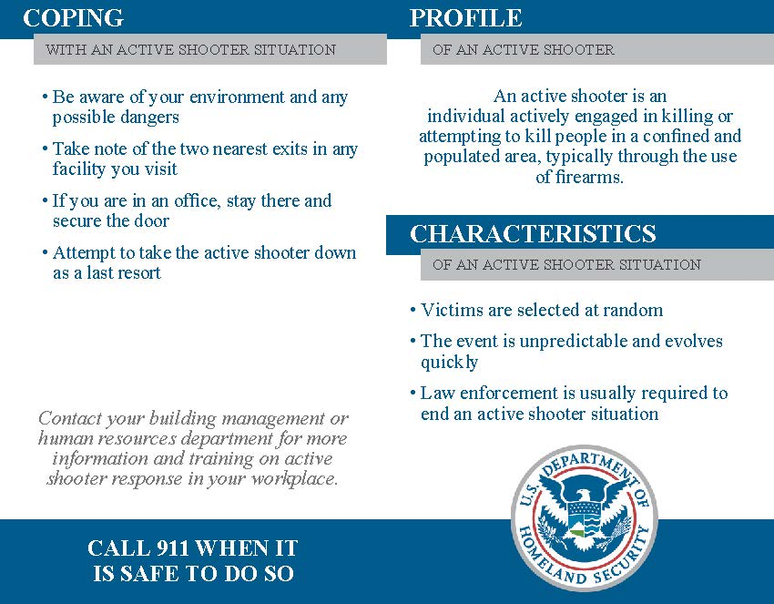

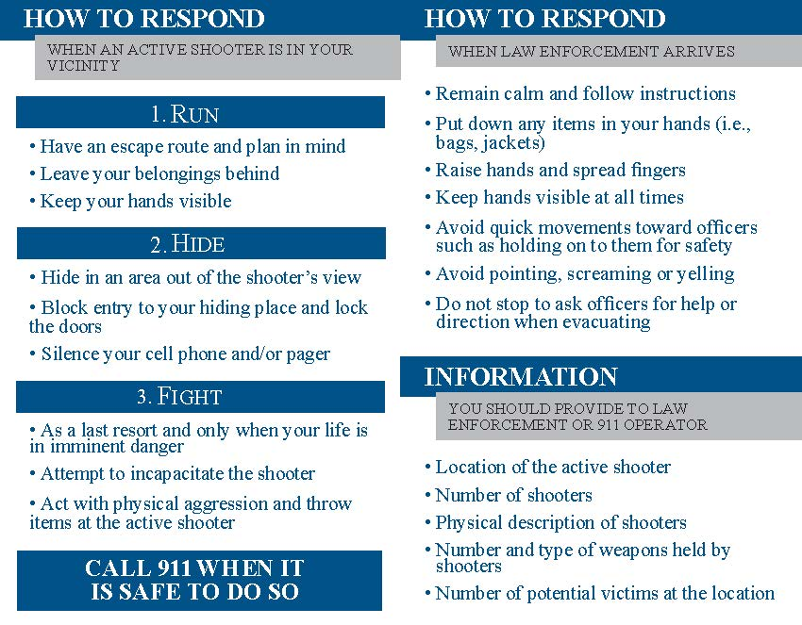

In Active Shooter situations it may not be a good idea to have one specific pre-designated “Safe Area” where floor occupants would automatically go to as Active Shooter situations are each unique and dynamic. Therefore, floor occupants should respond accordingly taking into consideration the information available at that time and make the best decision as to whether to run, hide, or fight. However, it is recommended that floor occupants make themselves aware of any potential “Safe Areas” on their floor in advance of an incident for good situational awareness.

**Preparing for an Active Shooter Situation – Organizational Considerations**

* Conduct vulnerability assessment of office identifying opportunities to target harden the space.
* Create workplace violence policy and train all employees on policy.
* Create Emergency Action Plan ensuring all employees are familiar with the plans for evacuations, sheltering-in-place, and options for responding to an active shooter situation.
  + Seek external training opportunities for Active Shooter Response training.
* Create Business Continuity Plan and incorporate plans for alternate worksites or telecommuting in event of unforeseen disaster closing office for prolonged period of time.

**Workplace Violence**

You should be familiar with your firms’ workplace violence policy, if one exists, as well as the early warning signs of workplace violence such as:

* Angry outbursts
* Combativeness
* Overreaction to seemingly minor issues
* Indications of drug or alcohol abuse
* Displays of intolerance or social withdrawal

###### General Tenant Response

* Should you feel threatened by an angry or suspicious person, remove yourself immediately from the situation.
  + If you cannot remove yourself, listen quietly and do not argue with the person.
  + Remain observant but do not stare.
* If there is an immediate and/or imminent threat call 911 for an immediate police response, and when safe to do so notify your floor warden and property management.
  + If the person displays a weapon, or if it becomes an active shooter situation, consider response options for an active shooter situation identified above by DHS ; Run, Hide, Fight.
* If situation becomes a hostage situation:
  + Remain calm and non-threatening.
  + Move slowly, comply with demands, do not argue or resist.
  + Engage in conversation so long as it does not provoke the hostage taker; do not engage in political or ideological discussions.
  + Stay low if possible.
  + Do not attempt to escape unless there is an extremely safe opportunity highly likely to succeed.

###### Warden Team Response

* If a violent encounter occurs on occupant floor, immediately call 911 and alert others to the situation. When safe to do so, notify floor warden, property management and building security.
* If a weapon is displayed, or it becomes an active shooter situation consider response options for an active shooter situation identified above by DHS; Run, Hide, Fight.
* Move occupants to positions of safety away from the incident, if safe to do so, and stay out of that area until deemed safe or the “all clear” has been given.

***Promote and support a culture of “See Something Say Something”.***

**Evacuation Route Map, Floor Layouts**

Insert for each property